**Implementation The project**

**1 How to Set Up the Workers to Run On the Project**

1. Open the MathLab program
2. In the Home Menu ( ENVIRONMENT )
3. Select Parallel Drop Down Menu Will show up Select Manage cluster Profiles

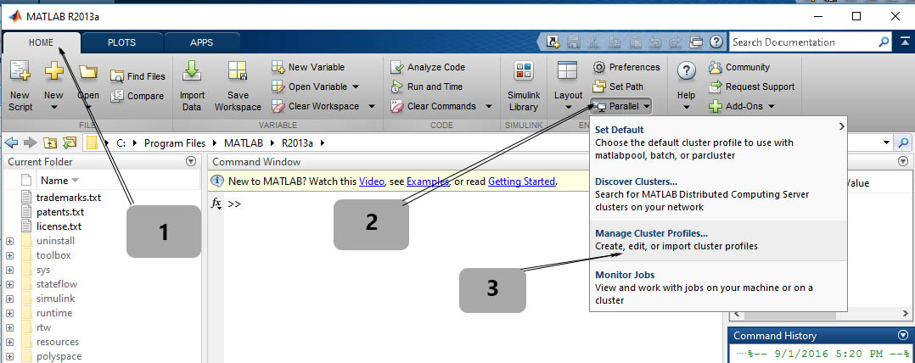

Fig ( 1 ) Set Workers ( 1 )

1. In the Cluster profile Select the Local and press Edit

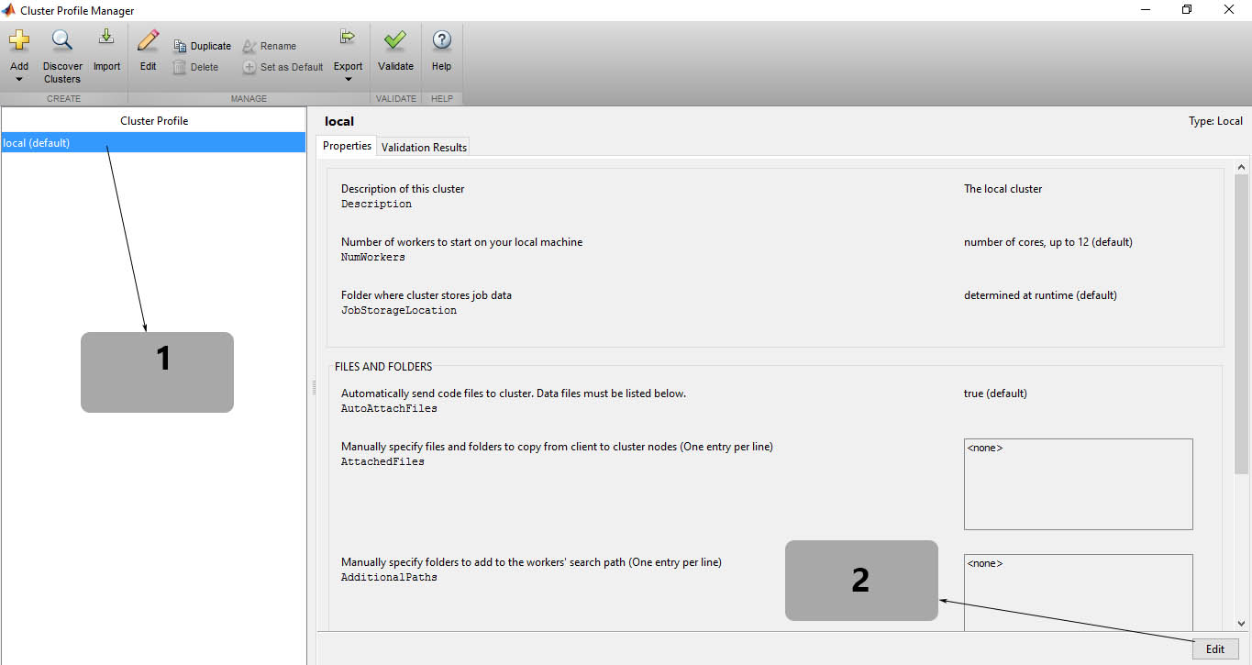

Fig ( 2 ) Set Worker ( 2 )

1. Set the ( Number of workers to start on your local machine NumeWorkers ) to (Number of logical core in your Machine e.g on the most CPU i5 it is 4 logical core and i7 8 logic core )
2. press the button Done and exit from Cluster Profile Manager window

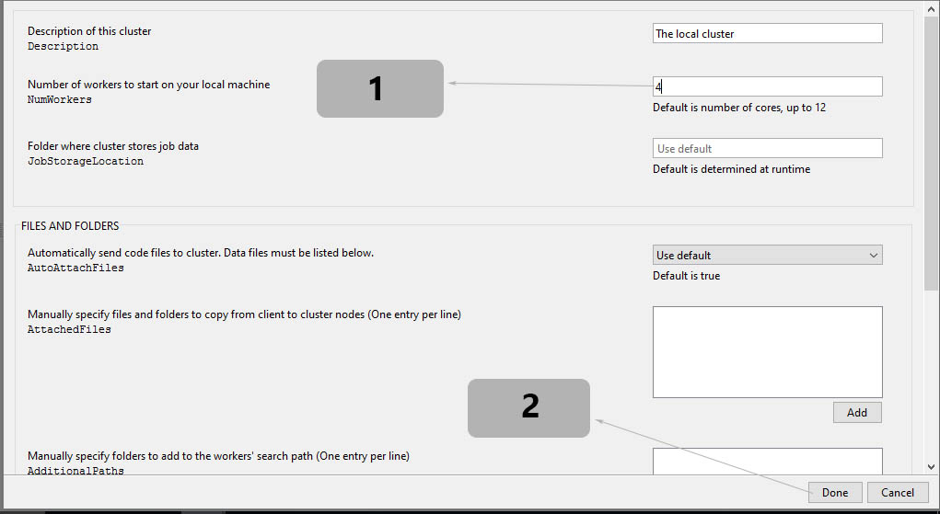

Fig ( 3 ) Set Workers ( 3 )

**2 How to Run the Course Project**

1. Open the Project from the MathLab Main Window press Open and brows the File and choose the “ Pararllel_Processing.m “ and press Run
2. The Following Windows Will be Appear

Fig ( 4 ) Project GUI Form

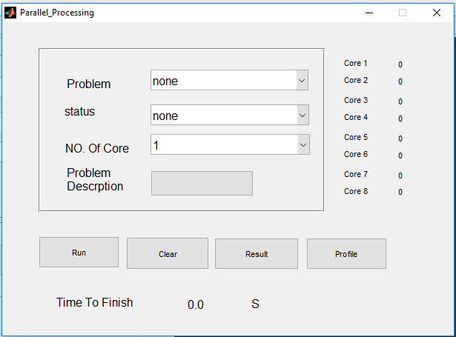

**3 Description The GUI Form Element**

1. Problem : the content the problem list to be solve for e.g (Cell Tower Optimization )
2. Statue : There Chose the Operation To Solve the Problem

* Sequenctial
* Parallel

1. No Of Core : Of you Choose the Parallel Operation This will be Active And you Can Control your Number Of Core to Be Run for Solving The Problem
2. Problem Description : there give you summary About The Algorithm Of The Problem
3. Core 1 to Core 8 : Save The Time you When You Solve The Problem in Every Core Run To See The Different
4. Buttons :
5. Run : Start Solve the problem Right Now And Show The Time After Finish
6. Clear : Set The Time Counter to Zero
7. Result : Open And See the Result in Bar ( See The Difference Graphically )
8. ProFile : Give you The Summary About the Function Thar Run And how Its Time The Take

1. Time Counter : Here Will Show the Time that Take to Solve The problem

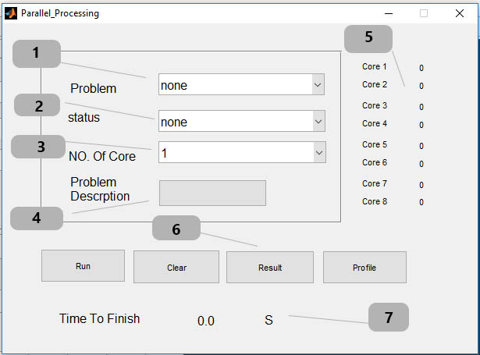

Fig ( 5 ) Project Element Detail

**4 How to Use the Program**

**4.1 Sequence process**

1- In The Problem : Choose the problem “ Cell Tower Optimization “ ( Note : the Description Button Will Active )

2- In The Status : Choose The Sequential Process ( note : The No Of Core Will be Disable Automatically )

3 - press On The Description Button To Read About The Problem ( Optional )

4 – Press The Run Button And Wait until it finish

5 – After finish the Current Execution Time in Second Will be Recorded

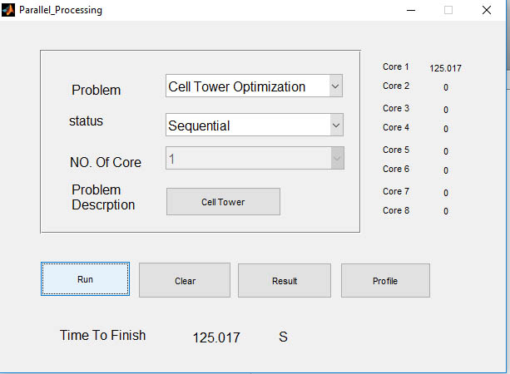

Fig ( 6 ) Sequence process

**4.2 Parallel Process**

1- In The Problem : Choose the problem “ Cell Tower Optimization “ ( Note : the Description Button Will Active )

2- In The Status : Choose The Parallel Process

3- In The No Of Core : Choose the Number of core you want to solve the problem ( The Maximum number Depend on your Computer Support for Example Core i5 CPU has 4

4- press On The Description Button To Read About The Problem ( Optional )

5 – Press The Run Button And Wait until it finish ( Note There Will Be Extra Time To Initialize the workers )

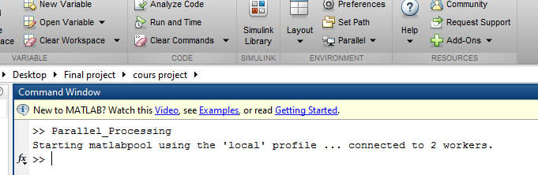

Fig ( 7 ) Created New Workers

6- After finish the Current Execution Time in Second Will be Recorded

7 – Repeat step 2 and 5 to see the Different Time Result And it Will be recorded in the Right Side

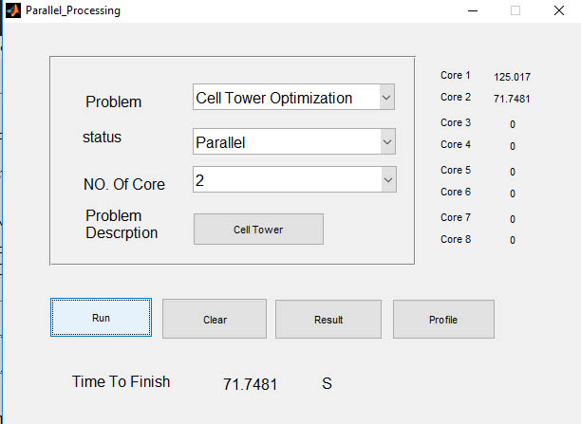

Fig ( 8 ) Parallel processing

9- press The Result Button to See The Different Time Require To Solve The Problem In Every Number of Core

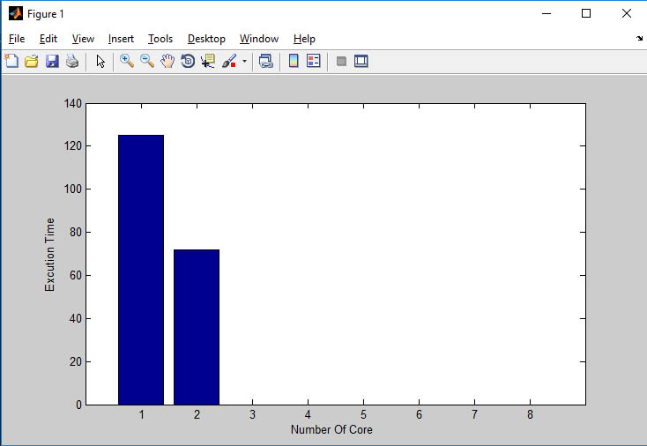

Fig ( 9 ) Execution Time with Number of Core

10 – Press The ProFile Button To See Summery How Many Function Work And How Much Take time

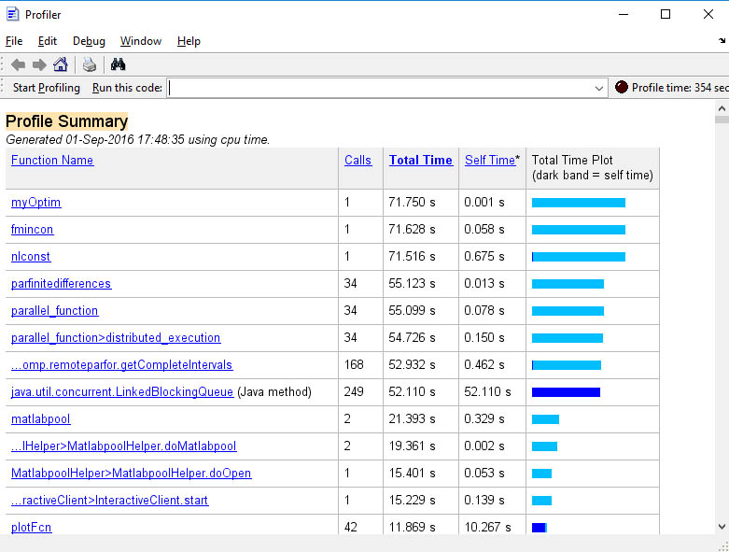

Fig ( 10 ) ProFile Summary